NAME: SURNAME: CLASS: NO: MARK:
A.Read the text and answer the questions. (E10.3.R2) 15P
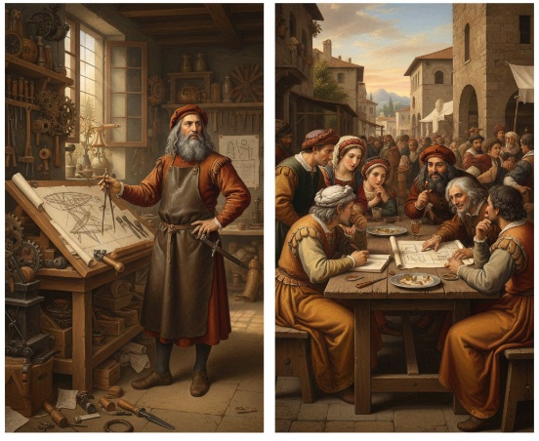
From Workshop to Ideas Shared www.maarifingilizce.com instagram: maarif_ingilizce
Yesterday morning, Leonardo got up early because he had an important day. First, he prepared his tools carefully in his workshop. Then, he worked on a new invention for several hours. In the afternoon, he met some people and shared his ideas with them. At the end of the day, he felt very tired but proud of his work.

1.Why did Leonardo get up early?
……………………………………………………………
2. What did he do after he prepared his tools?
……………………………………………………………
3. How did he feel at the end of the day?
……………………………………………………………
B.Read the text and answer the questions. (E10.4.R1) 30P
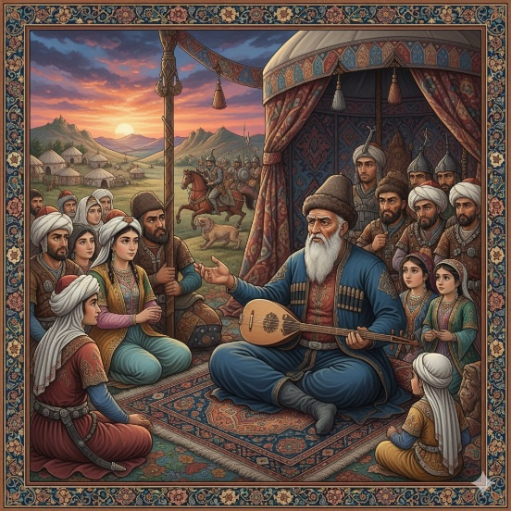
Living Before Technology
In the past, people used to watch shadow plays and listen to traditional stories for entertainment. They did not use to have personal computers or mobile phones. Children played games outside, and families spent more time together in the evenings.
1.What did people use to watch for entertainment?
……………………………………………………………
2. Did people use to have personal computers?
……………………………………………………………
3. Where did children usually play in the past?
……………………………………………………………

C. Write about one future plan of yours according to the instructions below. (E10.2.W1) 20p
-Use be going to or will. (Example structures: I am going to…, I think I will…, I won’t…)
- Write at least 3 short sentences
…………………………………………………………………………………………………………………………………………………………………………………………………………………………………………………………………………………………………………………………………………………………………………………………………………
D. Read the text and answer the questions. (E10.4.R2) 15P
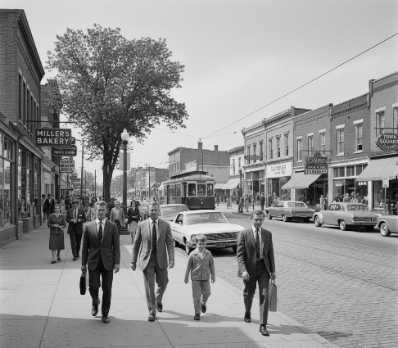
Moving from Past to Present
Fifty years ago, there didn’t use to be heavy traffic in big cities. People used to walk more and travel shorter distances. Most families lived in smaller towns, and life was slower. Today, cities are more crowded, traffic is heavier, and people use cars and technology much more in their daily lives.

1. Was traffic heavy in big cities in the past?
…………………………………………………………………………………………………
2. How did people use to travel more in the past?
…………………………………………………………………………………………………
3. How is city life today? …………………………………………………………………………………………………

E. Read the unfinished story and write an ending (at least) 3 short sentences. (E10.3.W1) 20P
(Use Past Simple or Past Continuous)
Wondering What’s Behind
While he was walking in the forest, he heard a sudden noise behind him. He immediately stopped and looked around carefully. The wind was blowing and the trees were moving. Then he saw a …
……………………………………………………………………………………………………………………………………………………………………………………………………………………………………………………………………………………………………………………………………………………………………………………………………………………………………………………………………………………………………………
Answer Key
A.Read the text and answer the questions. (E10.3.R2) 15P
From Workshop to Ideas Shared
Yesterday morning, Leonardo got up early because he had an important day. First, he prepared his tools carefully in his workshop. Then, he worked on a new invention for several hours. In the afternoon, he met some people and shared his ideas with them. At the end of the day, he felt very tired but proud of his work.

1.Why did Leonardo get up early?
→ Because he had an important day.
2. What did he do after he prepared his tools?
→ He worked on a new invention.
3. How did he feel at the end of the day?
→ He felt tired but proud.
B.Read the text and answer the questions. (E10.4.R1) 30P
Living Before Technology
In the past, people used to watch shadow plays and listen to traditional stories for entertainment. They did not use to have personal computers or mobile phones. Children played games outside, and families spent more time together in the evenings.
1.What did people use to watch for entertainment?
→ They used to watch shadow plays.
2. Did people use to have personal computers?
→ No, they didn’t.
3. Where did children usually play in the past?
→ Outside.

C. Write about one future plan of yours according to the instructions below. (E10.2.W1) 20p
-Use be going to or will. (Example structures: I am going to…, I think I will…, I won’t…)
- Write at least 3 short sentences
- I am going to study at university in the future. I will work very hard to reach my goal.
- I think I will be a teacher in ten years. I am going to help students learn English.
D. Read the text and answer the questions. (E10.4.R2) 15P
Moving from Past to Present
Fifty years ago, there didn’t use to be heavy traffic in big cities. People used to walk more and travel shorter distances. Most families lived in smaller towns, and life was slower. Today, cities are more crowded, traffic is heavier, and people use cars and technology much more in their daily lives.

1. Was traffic heavy in big cities in the past?
→ No, it wasn’t.
2. How did people use to travel more in the past?
→ They used to walk more.
3. How is city life today?
→ It is faster and more crowded. (or: Cities are more crowded today.)
E. Read the unfinished story and write an ending (at least) 3 short sentences. (E10.3.W1) 20P
(Use Past Simple or Past Continuous)
Wondering What’s Behind
While he was walking in the forest, he heard a sudden noise behind him. He immediately stopped and looked around carefully. The wind was blowing and the trees were moving. Then he saw a …
- Then he saw a wild animal near the trees. He quickly ran away.
- Then he saw a strange shadow behind him. He felt very scared.

