2025-2026 ACADEMIC YEAR
............................................................SECONDARY SCHOOL 1ST TERM 2ND ENGLISH EXAM FOR THE 6TH GRADES

Name:_____________________________

E6.1.R1
Class: ________
6TH GRADES

- READ THE TEXT AND ANSWER THE QUESTIONS.

Hi! I’m Elif. I go to school on weekdays. I like my school very much.
After school, I usually do my homework at home. Then I have some free time.
On Thursdays, I go to a dance course. I like dancing and listening to music.
At the weekend, I don’t go to school. I rest at home and visit my grandparents.
I feel happy when I spend time with my family.
When does Elif go to school?
→ …………………………………………………………….................................. What does Elif usually do after school?
→ ……………………………………………………………................................... What does Elif do on Thursdays?
→ …………………………………………………………….................................. How does Elif feel at the weekend?
→ …………………………………………………………….....................................

E6.2.R1
- READ THE TEXT AND COMPLETE

I usually have a nutritious breakfast. I eat eggs and drink milk every morning. I like muffins, but I eat them only at the weekend. I don’t eat junk food like cola and chips because it is unhealthy.

healthy food
___________________
___________________
___________________

unhealthy food
___________________
___________________
___________________

favorite food
___________________
___________________
___________________

E6.4.R1.
- COMPLETE THE TABLE ACCORDING TO THE TEXT.





In the morning, the weather is rainy and windy. The sky is cloudy, and people use umbrellas. Because of the bad weather, some people feel moody and unhappy.
In the afternoon, the rain stops, and the weather becomes sunny and warm. People go outside, and they feel happy and relaxed.
How’s the weather?
In the morning ………………………………………
In the afternoon ……………………………………....

How are they feeling?

In the morning ……………………………………… In the afternoon ………………………………………

E6.3.R1.
6TH GRADES
- READ THE SENTENCES AND WRITE EHERE THEY LIVE. DOWNTOWN OR VILLAGE

Elif

Mert

Zeynep
There are many cars near my house. The streets are crowded, and there is a lot of traffic. I can see tall buildings and shops around.
My house is small and quiet. There are no tall buildings here. People walk slowly, and there is little traffic.
I usually walk to places because everything is close. There are many shops and kiosks near my home.

Ali
My home is peaceful. There are few shops, and the streets are never crowded.

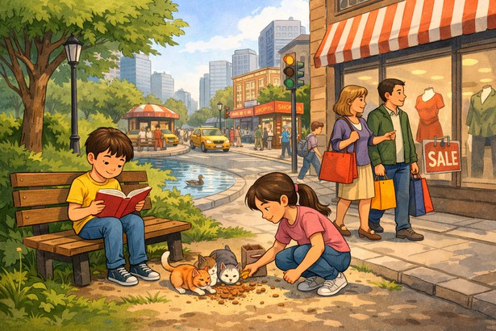



Write Downtown or Village for each child.
1. Elif lives in: ____________________
2. Mert lives in: ____________________
3. Zeynep lives in: __________________
4. Ali lives in: ____________________

E6.3.R1.
- LOOK AT THE PICTURE AND ANSWER THE QUESTIONS

Look at the picture and tick (✓) what you see.
  - Ali is reading a book in the park.
  - Ali is feeding the cats.
  - Ali’s sister is feeding the cats near the street.
  - Ali’s sister is reading a book.
  - Their parents are shopping downtown.
  - The family is at home.

  - There are three cats in the street.
TEACHER’S NAME

