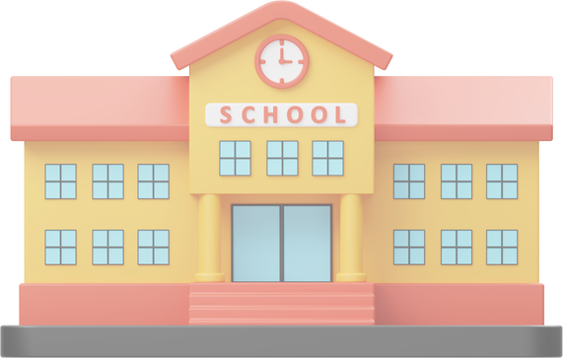
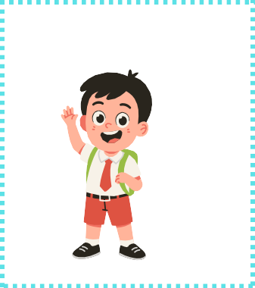
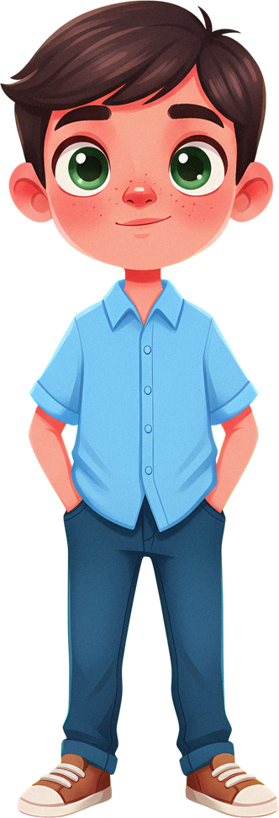

2025-2026 ACADEMIC YEAR
........................................................... SECONDARY SCHOOL 1ST TERM 2ND ENGLISH EXAM FOR THE 5TH GRADES

Name:____________________________

ENG.5.1.R4
Class: ________
5TH GRADES

- READ THE TEXT AND ANSWER THE QUESTIONS.
Hello! I’m Emre. I am a student at this school. I like spending time in the library because it is quiet. I am a member of the science club, and we organise small experiments after school. At school, we mustn’t shout in the classroom, and we must follow the rules. On 23 April, we celebrate National Sovereignty and Children’s Day with our teachers and friends.
✍ Questions:
- Which place does Emre like at school? Why?
→ ......................................................................................................
- Which school club is Emre a member of?
→ .....................................................................................................
- Write one school rule mentioned in the text.
→ .....................................................................................................

ENG.5.2.W4
- WRITE ONE SUITABLE WORD OR PHRASE FOR EACH BLANK.
- In our classroom, we mustn’t _ .
- My favourite subject is _ .
- We have ______________________________________ lesson on _ .
- There is a in my classroom.
- Our school starts at _ .

www.maarifingilizce.com instagram: maarif_ingilizce

(ENG.5.3.R3)
- READ THE TEXT AND COMPLETE

Hi! I’m Leo. I am twelve years old. I have short black hair and green eyes. In the morning, I get up at seven o’clock and wash my face. I wear a blue T-shirt and jeans. After school, I do my homework and play football. In the evening, I have dinner with my family.

physical features
___________________
___________________
___________________

morning activity
___________________
___________________
___________________

clothes
___________________
___________________
___________________

after-school activity
___________________
___________________
___________________


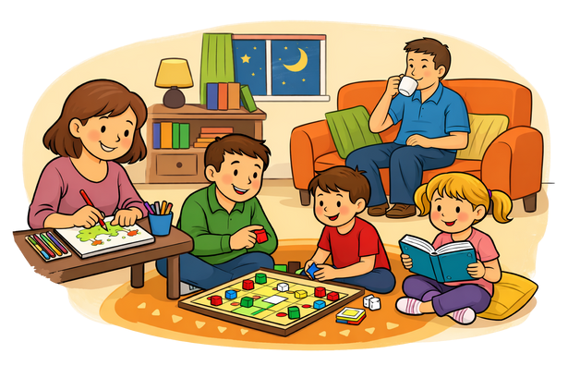



(ENG.5.3.R3)
- CHOOSE ANY THREE SENTENCES AND COMPLETE THEM ABOUT YOURSELF.
WWOORRDDSS
5TH GRADES

short hair – long hair glasses – school uniform a T-shirt – trousers -dress get up early – play games do my homework
have breakfast – read books go to school – play outside
- I have _ .

- I wear _ .

- In the morning, I _ .

- After school, I _ .

- In the evening, I _ .

ENG.5.4.V1
- LOOK AT THE PICTURE. FIRST, TICK (✓) THE HOBBIES YOU SEE. THEN USE THEM TO COMPLETE THE TEXT.

🧩 Hobbies & Activities (tick what you see)
  - reading
  - drawing / painting
  - playing a board game
  - cooking together
  - talking / chatting
  - listening to music

Text the picture.
In the evenings, my family spend time at home. My mother likes __________________________ .
My father enjoys __________________________ . My brothers like __________________________ . My sister enjoys __________________________ .

TEACHER’S NAME

